Formal Lab Report – Sample A
Zackery E. Dragovich
Date Submitted: (11/28/2023)
CHEM-2081-004
GTA: Dominic Fico

Introduction
I Do not have the time to provide this
Observations
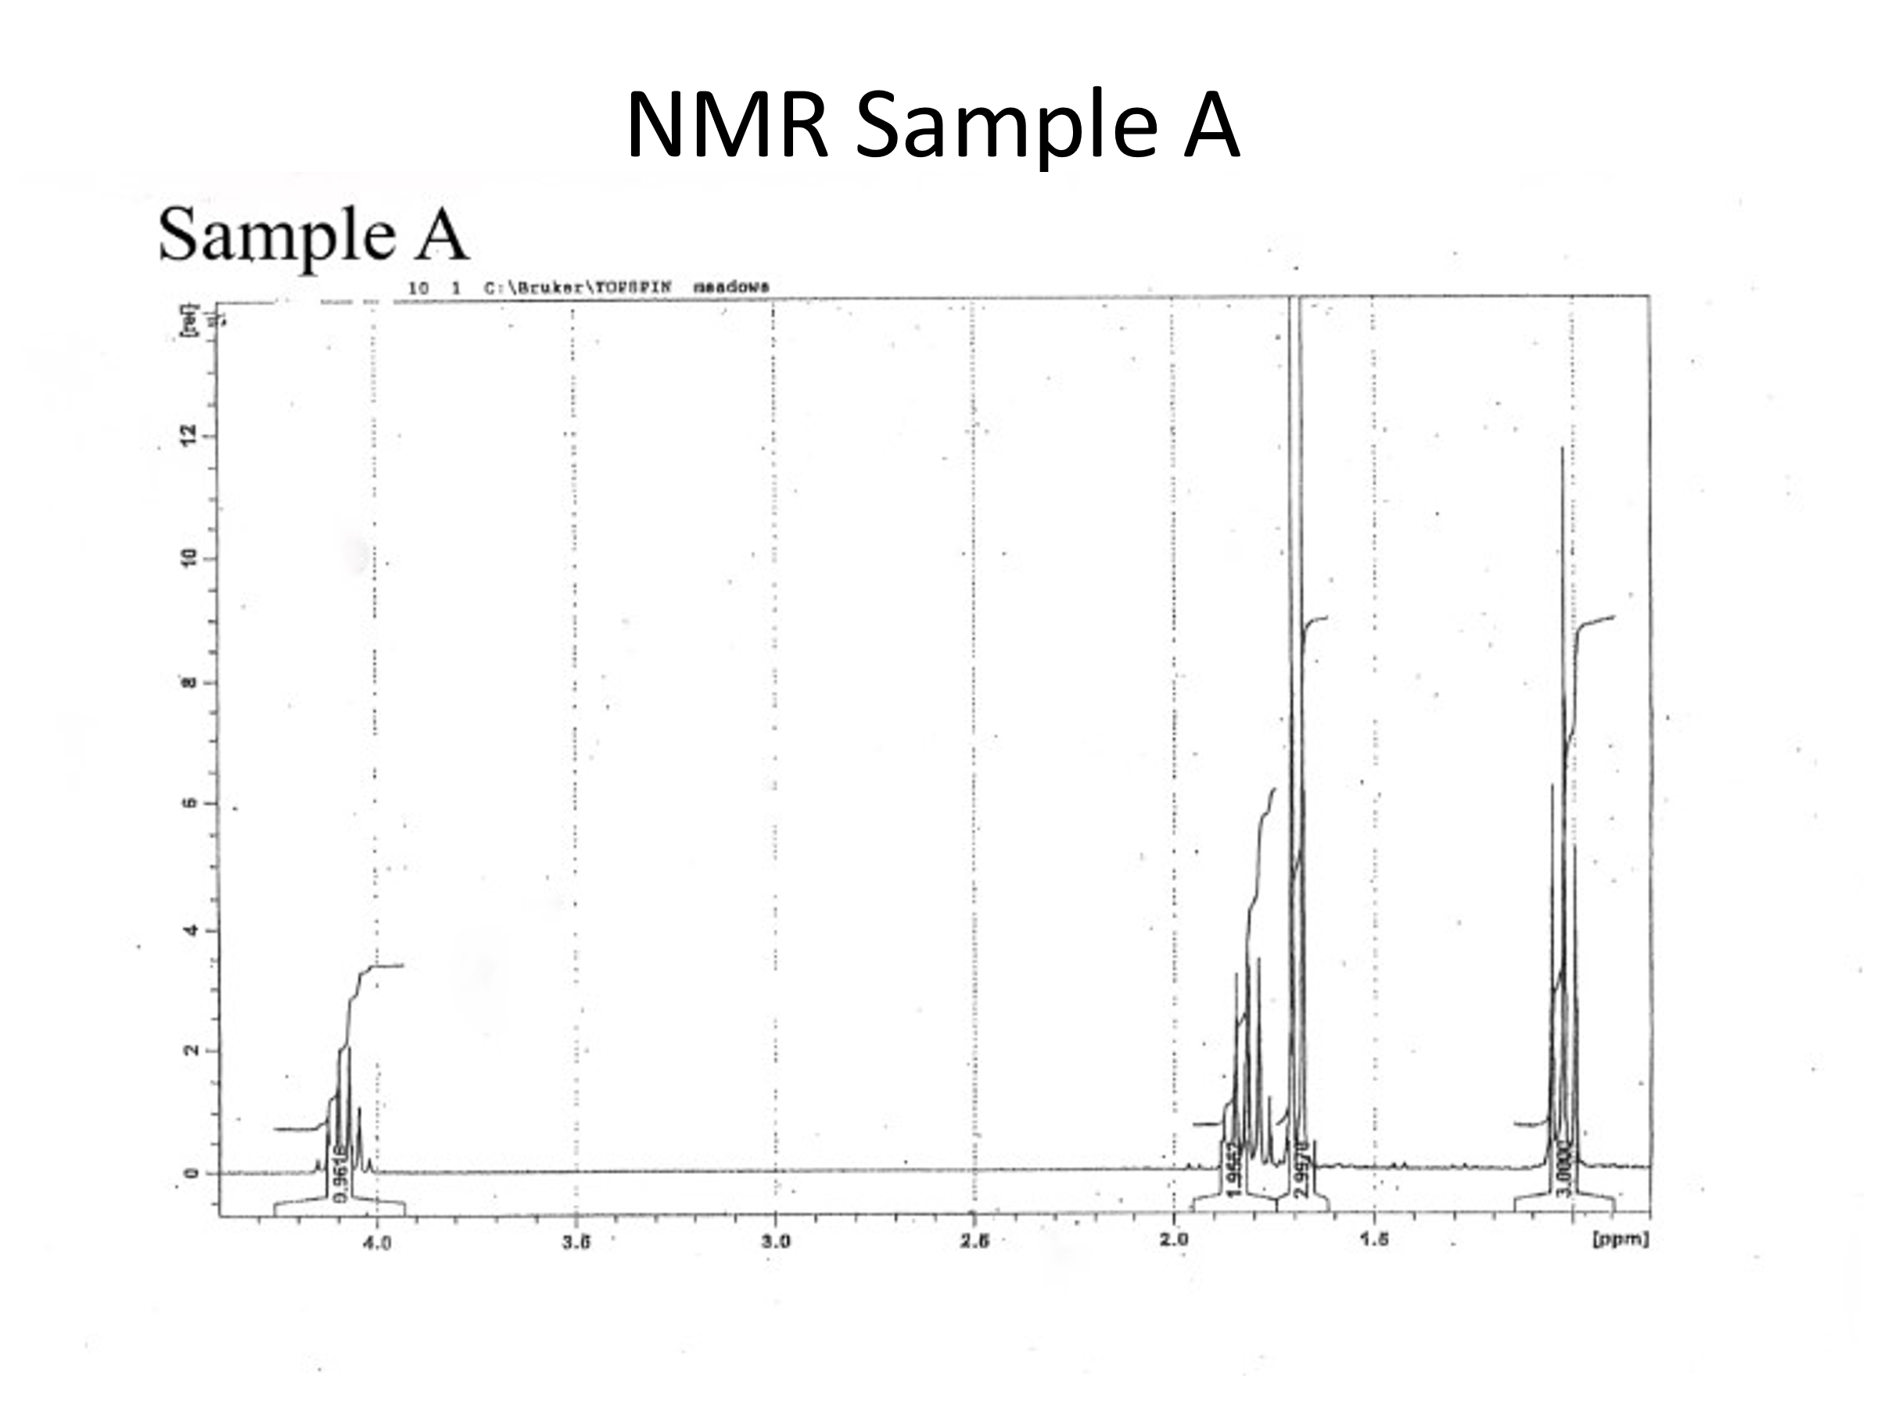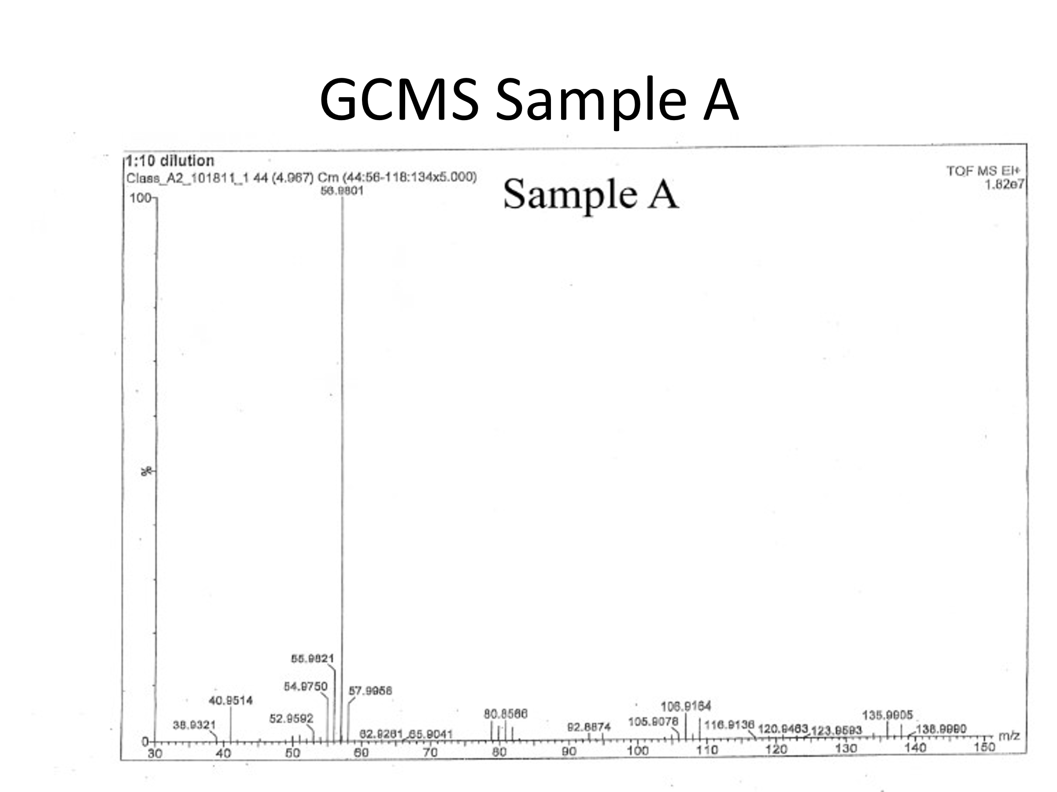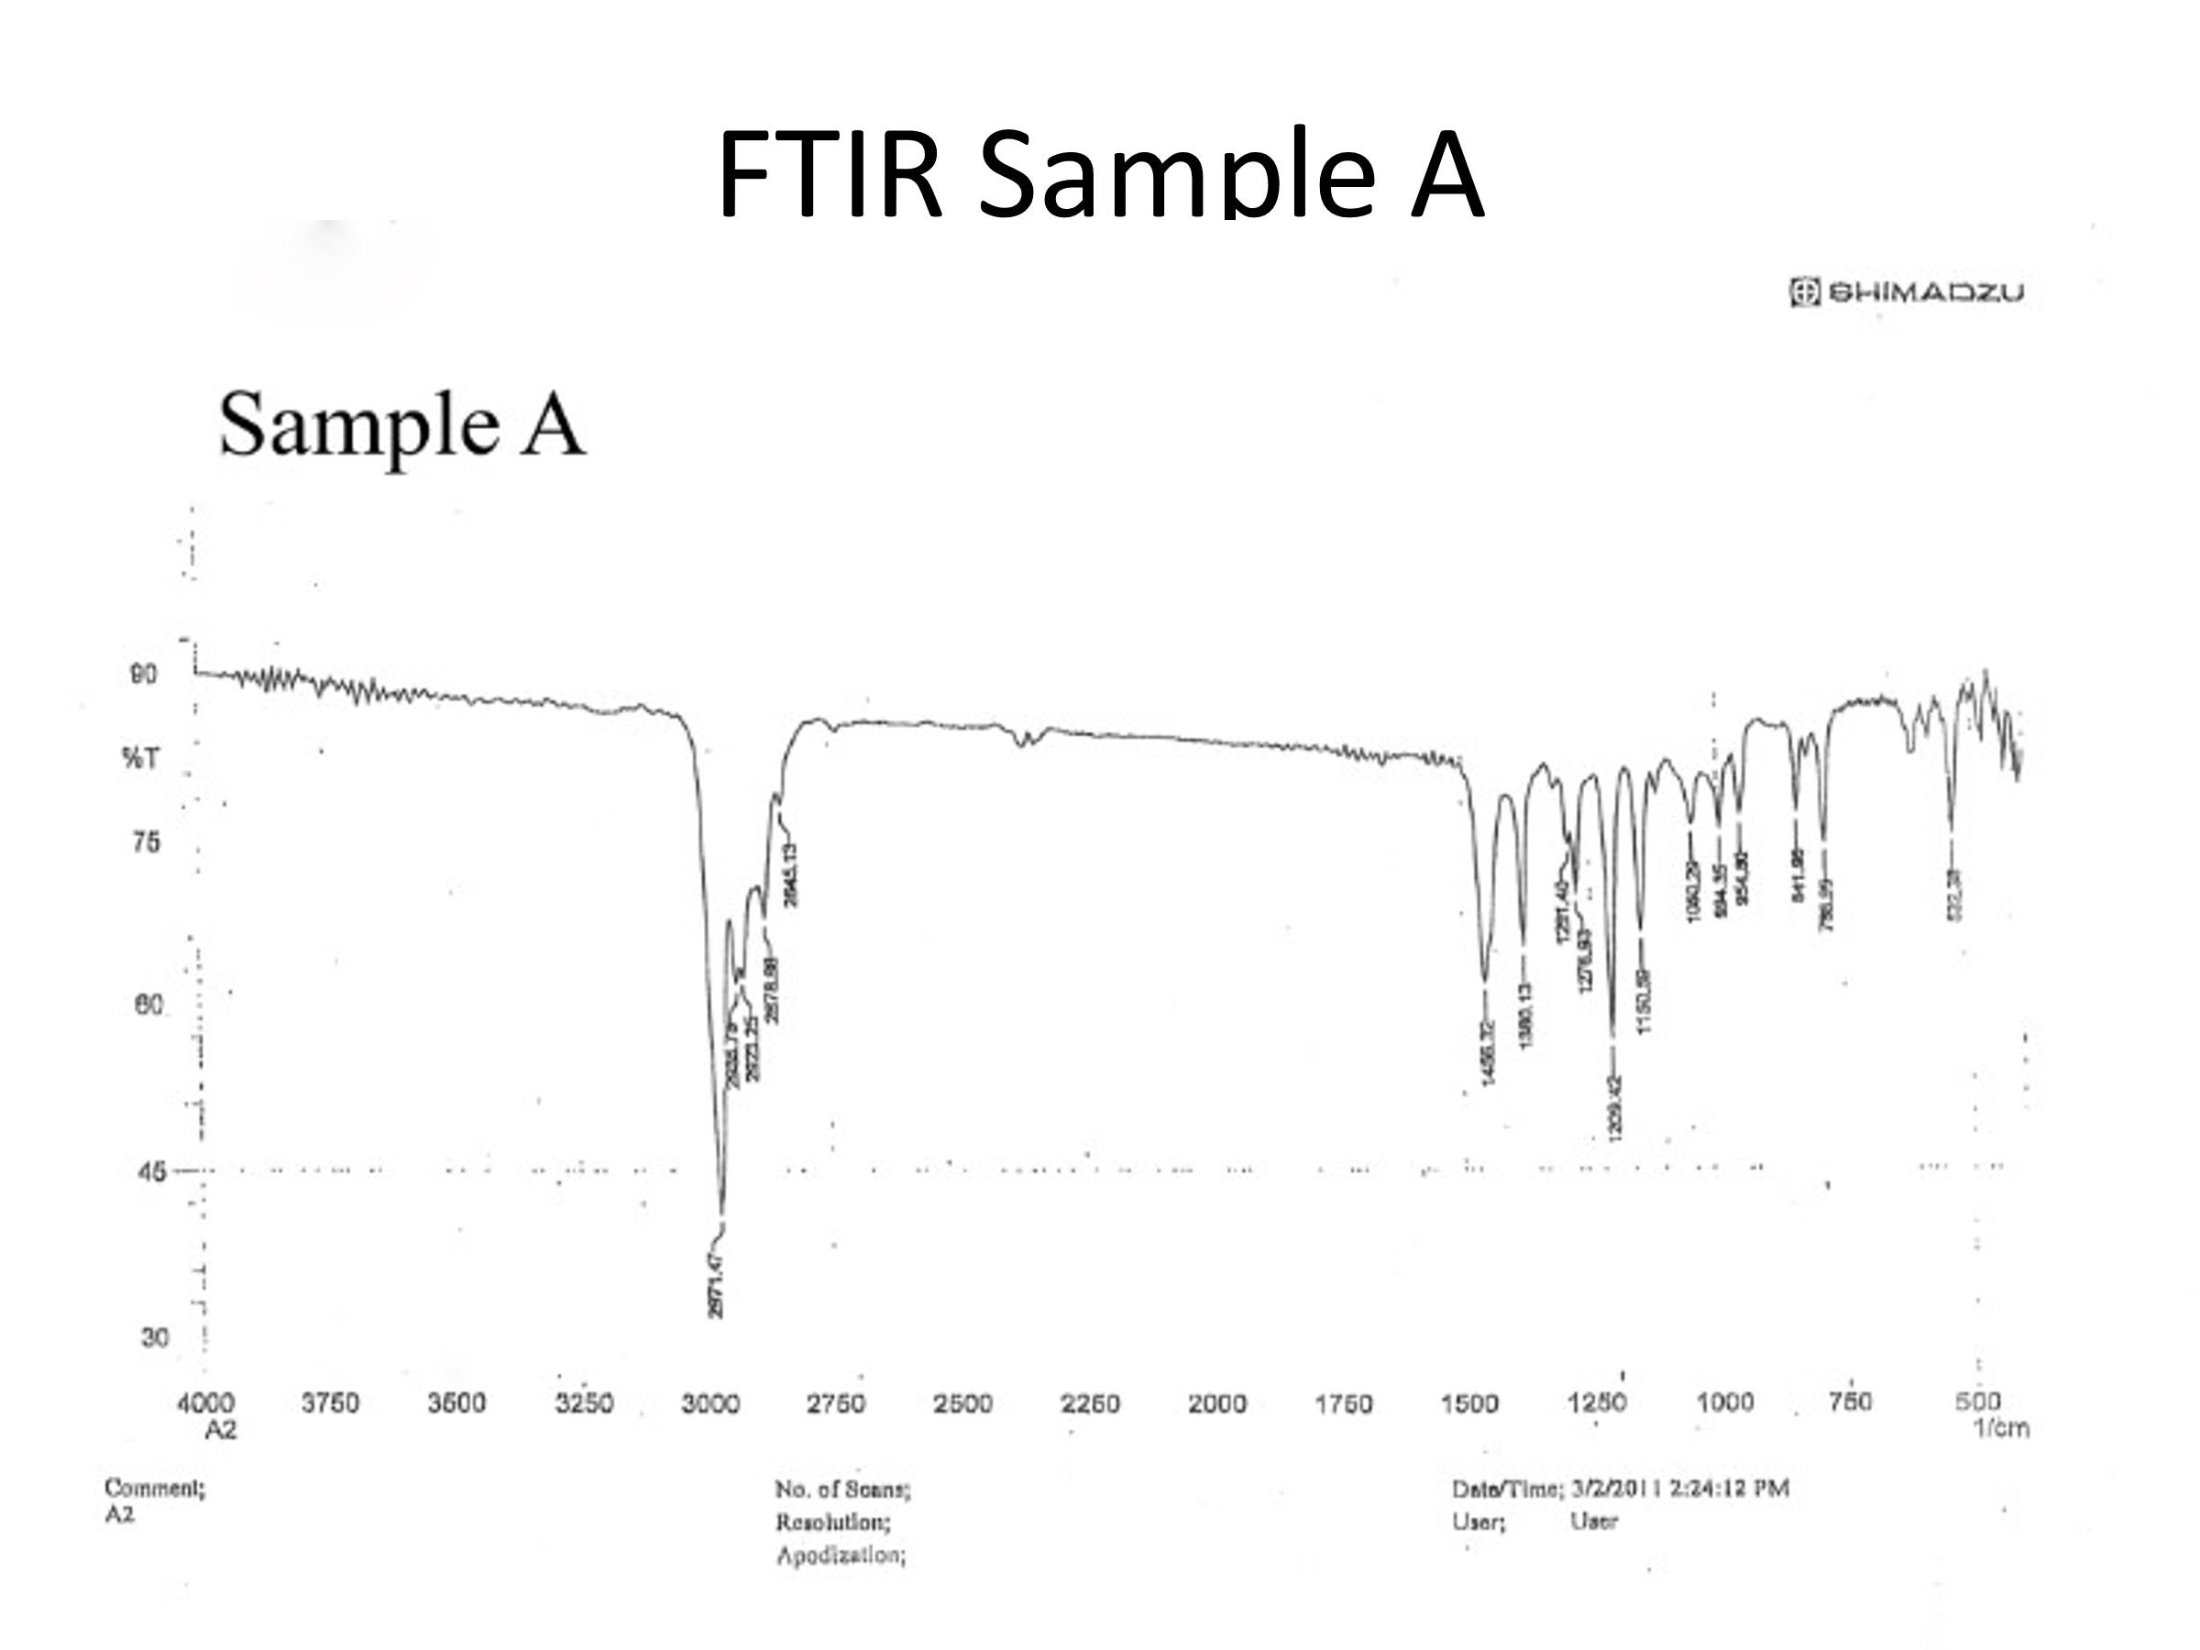

Conclusions
The identity of the chemical is most likely diisopropyl ether (C₆H₁₄O). For the IR Spectroscopy, it is typical to see an R₃CH group at 2850—3000 cm⁻¹. This is seen in the presented IR graph of the sample. Thus, it should be appropriate to assume that the group, or at the very least, a similar group, is in the sample. The chemical shift displayed in NMR suggests that there is an ether group, because it measures between 3.9—4.25 ppm, which falls between the 3.2—5.2 ppm range. The remaining data in the NMR graph would suggest that the compound is diisopropyl ether, which has 14 protons, which is just one more than the predicted from just nearby hydrogens from each atom alone. When pulling up NMR and IR graphs for a diisopropyl ether sample, the graphs for this sample line up nearly identically, which would suggest that the sample is indeed diisopropyl ether.
References
Keller L, Joseph K, and Miguel S. 2023 Fall. CHEM 2081 Organic Chemistry 2 Lab Manual [lab manual]. Auburn (Al): Auburn University.

